Name: Alon S. Levin

# Problem 1

Discuss how you determined the reference frequency and all scale / chord frequencies for this project.

I began with the equally-tempered scale; this was simple, as we know that the ratio of the frequencies of two “adjacent” (i.e. half step) tones is $\sqrt[12]{2}$. Beginning with A4=440Hz, it is trivial to calculate the frequencies of the other tones.

The just-tempered scale was more difficult. For this, I once again began with A4=440Hz; I then expanded the table to encompass all the keys and their enharmonics as nominally distinct tones. I calculated the ratio of sounds from A4 to the key of each scale using the “Complete Scale of Just Intonation” (from the Week 3 presentation); I was able to thus find the reference frequency for each scale, and thereby find the frequencies of each note in each scale, beginning with the major scales and then filling in the rest of the notes.

# Problem 4

The first set of graphs show a comparison of the equally- and just-tempered major chords, in two views: the first zoomed in on a single wavelength of the fundamental frequency (A4=440Hz) and the second on ten such wavelengths. This chord consists of three notes: root, major third, and perfect fifth. Initially, the two plots seem identical; however, they clearly diverge, with this effect being visible only ten wavelengths in.

Similarly, the second shows a comparison of the equally- and just-tempered minor chords, in two views: the first zoomed in on a single wavelength of the fundamental frequency (A4=440Hz) and the second on ten such wavelengths. This chord consists of three notes: root, minor third, and perfect fifth. As with the major chords, the two plots initially look almost identical; they begin to diverge slightly after several wavelengths, although not to the extent of the major chords (perhaps providing a reason for the two minor chords sounding more similar than the two major chords).

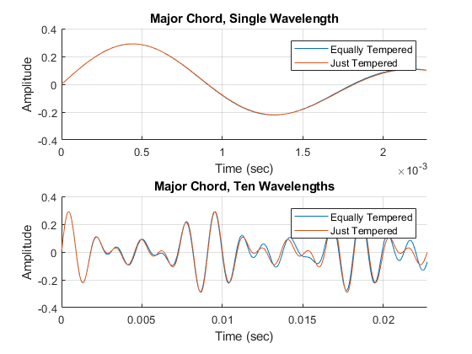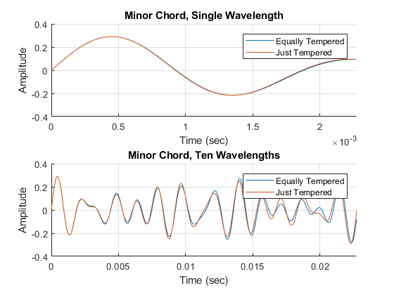

# Problem 5

1. Can you hear the difference between the just tempered Major scale and the equal tempered Major scale?
   1. I heard a bit of a difference, but not by very much. Looking at the frequencies calculated in the chart, the difference is very subtle, which could explain why they sounded very similar.
2. Which one sounds better? - Why (explain)
   1. As I said above, the two sounded very similar to me. However, for me, the first (just-tempered) sounds a bit “cleaner” than the second (equal-tempered); I presume that this is because of the natural ratios between the frequencies.
3. Can you hear the difference between the just tempered Minor scale and the equal tempered Minor scale?
   1. As with the major scales, the two sound very similar to me, again presumably due to the frequencies being relatively similar between just-intonation and equal-intonation scales.
4. Which one sounds better? - Why (explain)
   1. The just-tempered scale once again sounds better than the equally-tempered scale, being “cleaner” in my opinion than the latter.
5. Can you hear the difference between the just tempered Major chord and the equal tempered Major chord?
   1. This time I distinctly heard a difference – it sounded as though beats were present in the equally-tempered major chord that were not present in the just-tempered chord.
6. Which one sounds better? - Why (explain)
   1. The beats are a bit off-putting in the equally-tempered chord; the just-tempered chord is definitely more pleasant.
7. Can you hear the difference between the just tempered Minor chord and the equal tempered Minor chord?
   1. I did not hear any beats in either of these chords. However, the just-tempered chord sounded a bit clearer than the equal-tempered chord.
8. Which one sounds better? - Why (explain)
   1. Once again, the just-tempered chord sounded better, as it sounded clearer and seemed to “ring” less than equal-tempered chord.

# Other Comments

When I first ran the code with sound output, all of the scales and chords played simultaneously; because of this, I changed from using the “soundsc” function to creating an audioplayer object for each sound. However, I ran into an interesting problem: whereas soundsc would play the chords well, the audioplayer would output a very different (and arguably worse) sound until the amplitude was brought down. For this reason, the chords play at a lower volume than the scales; I have not found a different solution to this as of yet.